HTML links

Table of content

* What is HTML link?
* What is HTML link and explain its syntax?
* Which type of links can be provided to the HTML document?
* What is internal link or relative link and explain its Example?
* What is external link and explain its example?
* Explain HTML link color.
* What is a concept of link bookmark?

What is HTML link?

In HTML document, Link or hyperlink is use for providing a link which is use for connecting one webpage to another. For providing link to the document ‘a’ tag means anchor tag is used. Anchor tag will provide correct link destination to the document. Anchor tag followed by link of the particular webpage. By using link or hyperlink it is easy to insert any video, image or any sound bite to the HTML document.

Example-

<html>

<head>

            <title>link tag</title>

</head>

    <body>

        <a href=https://geeky4u.com>click here to visit us</a>

    </body>

</html>

Output-



What HTML link and explain its syntax?

Anchor tag is used for providing a link to the HTML document. In HTML document, link tag is use to provide a link between two pages. It will take you on the same page which you have mention as a link in the given tag. <a> tag use to represent hyperlink which is also known as anchor tag. Anchor tag is having HREF as an attribute.

Syntax-

<a href=”link”> text</a>

**HREF** strands for **“hypertext reference”** which is use for give a link of browser, file e-mail etc.

Example-

<html>

<head>

            <title>link tag</title>

</head>

    <body>

        <a href=https://www.google.com>click here to visit google</a>

    </body>

</html>

Output-



NOTE-All the browser will support to the link which is provided in the HTML document.

Which type of links can be provided to the HTML document?

* HTML link with target attribute-
* HTML link to insert an image-
* HTML link for providing email address-
* HTML link for providing button-

HTML link with target attribute-

HTML link is supported by all the browsers as well as link URL will open by default in the same window page where the output of the link attribute is opened. In case if user wish to change new tab window the target attribute in the HTML link will help to set the target where user wish to open the link which is provided in HTML document.

There are some condition and some tags use to set target attribute

* **_self-** It is default way to open the link. HTML link will open by default link URL will open by default in the same window page where the output of the link attribute is opened.
* **_blank-** It will help to link to open in the new tab window.
* **_parent-** Document with the parent will helps to the document to open in the parent frame
* **_top-** It will occupy full body of the window.

Example-

<html>

<head>

            <title>link tag</title>

</head>

    <body>

        <a href=https://www.geeky4u.com target="_blank">Visit us</a>

    </body>

</html>

Output-



HTML link to insert an image-

HTML link is also useful for inserting an image to your HTML document. There are two ways to insert an image such as provide a link or path of image in your local host or provide a link via web.

Example-

<!DOCTYPE html>

<html lang="en">

  <head>

    <meta charset="UTF-8" />

    <meta name="viewport" content="width=device-width, initial-scale=1.0" />

    <title>Document</title>

  </head>

  <body>

    <img

      src="https://images.unsplash.com/photo-1517218313419-97711ffe5493?crop=entropy&cs=tinysrgb&fit=crop&fm=jpg&h=400&ixid=eyJhcHBfaWQiOjF9&ixlib=rb-1.2.1&q=80&w=400"

      width="300"

      height="300"

    />

  </body>

</html>

**Output-**



HTML link for providing email address-

By using HTML link tag user can fire a mail to the client.

Syntax-

<a href=”xyz@mail.com”>send email </a>

Example-

<!DOCTYPE html>

<html lang="en">

<head>

    <meta charset="UTF-8">

    <meta name="viewport" content="width=device-width, initial-scale=1.0">

    <title>Document</title>

</head>

<body>

     <a href="xyz@mail.com">send to</a>

</body>

</html>

Output-



HTML link for providing button-

HTML link is use for providing link in the form of button. If you click on the button then it will directly navigate to the link which is provided into the link tag.

Example-

<!DOCTYPE html>

<html>

<head>

      <title>image tag</title>

   </head>

   <body>

      <h1>geeky4u.com</h1>

       <button onclick="https://geeky4u.com/">our official website</button>

   </body>

</html>

Output-

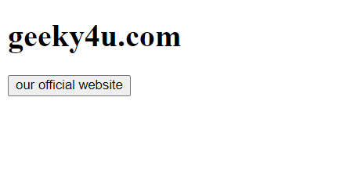

What is internal link or relative link and explain its Example?

Internal link is a concept of providing a link which is applicable only up to the local host or up to the domain. Internal link consists of an image which is saved on your local host or the document or some important content within the scope of your domain.

Example- (This is an example of relative URL provided to the link.)

<html>

  <head>

    <title>internal link tag</title>

  </head>

  <body>

    <h3>You can give reference of your local file also</h3>

    <a href="image 2.jpg">

      Click to view

    </a>

    <h3>Here you can visit terms and condition page of GEEKY4U </h3>

        <a href=https://geeky4u.com/terms-conditions-geeky4u>

        click to see Terms and conditions. </a>

  </body>

</html>

Output-

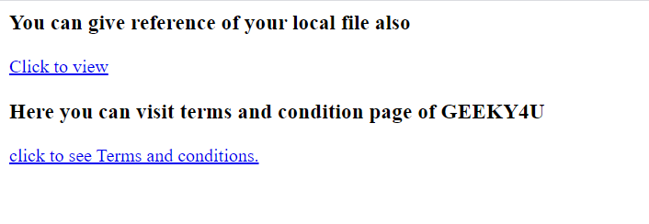

What is external link or absolute link and explain its example?

External link is accessible as a worldwide. External link means if user wants to add an image which is not saved in local computer so that user can add an image link via web also. External link will allow the user to add any valid URL of a particular website.

Example-(This is an example of absolute URL provided to the link.)

<html>

<head>

            <title>external link tag</title>

</head>

    <body>

           <h2>Here you can give absulute URL which is access by worldwide. </h2>

           <h3>1.By using this link you can visit to Google page.</h3>

           <a href=https://google.com> click to visit Google page. </a>

           <h3>2.By using this link you can visit to Facebook page.</h3>

           <a href=https://facebook.com> click to visit Facebook page. </a>

    </body>

</html>

Output-

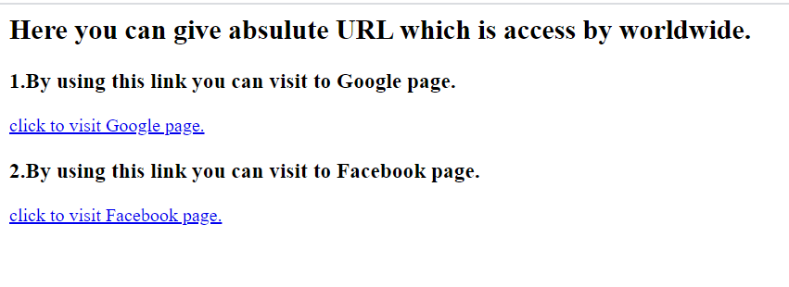

Explain HTML link color.

HTML supports different link color in which by default browser will show the color of the link according to the dependency. There are three types of link visited link, unvisited link and active link.

Types of links-

* Visited link is in underline and having purple color.
* Unvisited link represented in underline as well as in blue color
* Active link represented in underline as well as in red color

Example- (This is an example of visited link for default browser).

<!DOCTYPE html>

<html lang="en">

<head>

    <meta charset="UTF-8">

    <meta name="viewport" content="width=device-width, initial-scale=1.0">

    <title>Document</title>

</head>

<body>

   <a href="https://geeky4u.com/">visit us</a>

</body>

</html>

Output- In the output you can see the color of the link is purple and there is underline you can see below the link. But By using CSS properties in HTML you can change the color of the link and make changes accordingly.



Example- (This is an example of customized visited link)

<!DOCTYPE html>

<html lang="en">

  <head>

    <meta charset="UTF-8" />

    <meta name="viewport" content="width=device-width, initial-scale=1.0" />

    <title>Document</title>

    <style>

      a:visited {

        color: green;

      }

    </style>

  </head>

  <body>

    <h4>

      here you can give color accordingly. I have given green color to the link

    </h4>

    <a href="https://geeky4u.com/">visit here</a>

  </body>

</html>

**Output-**

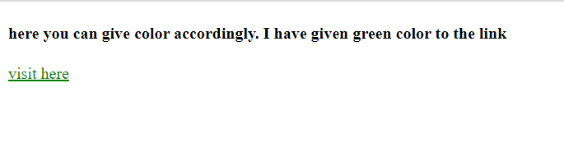

Example **(**This is an example of link by using visited, active, and hover property).

<!DOCTYPE html>

<html lang="en">

<head>

    <meta charset="UTF-8">

    <meta name="viewport" content="width=device-width, initial-scale=1.0">

    <title>Document</title>

    <style>

        a:visited{

            color: green;

        }

        a:active{

            color: pink;

        }

        a:hover{

            color:red;

        }

    </style>

</head>

<body>

    <h4>here you can give color accordingly.</h4>

    <a href="https://geeky4u.com/">click  here</a>

</body>

</html>

**Output-**

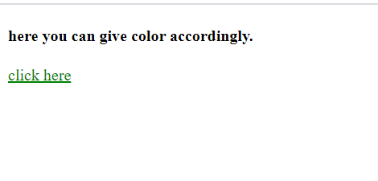

Output- This is an output of hover link



Note- Hover is a link which is only effective when you put your mouse pointer on the link.

Note- Active link exactly comes after the hover link. If you click on the link within a second color will change.

What is a concept of link bookmark?

This bookmark concept is important when it comes to the larger text in the document. If your text document is very large and it is very difficult to find exact content of the text then HTML allow to create a bookmark.

For creating a bookmark, link needs to be attached in the document so that it is easy to navigate. Link can be written in the <a> tag with href attribute.

Example-

<!DOCTYPE html>

<html>

  <body>

    <p><a href="#paragraph5">Go to Paragraph 5</a></p>

    <h3>Paragraph 1</h3>

    <br />

    Lorem ipsum dolor sit amet consectetur adipisicing elit. Natus, autem<br />

    fugiat voluptas omnis officiis quasi vero totam ad ratione, doloribus<br />

    distinctio commodi animi et? Fugit, quod. Optio assumenda consequatur<br />

    veritatis

    <h3>Paragraph 2</h3>

    <br />

    Lorem ipsum dolor sit amet consectetur adipisicing elit. Natus, autem<br />

    fugiat voluptas omnis officiis quasi vero totam ad ratione, doloribus<br />

    distinctio commodi animi et? Fugit, quod. Optio assumenda consequatur<br />

    veritatis

    <h3>Paragraph 3</h3>

    <br />

    Lorem ipsum dolor sit amet consectetur adipisicing elit. Natus, autem<br />

    fugiat voluptas omnis officiis quasi vero totam ad ratione, doloribus<br />

    distinctio commodi animi et? Fugit, quod. Optio assumenda consequatur<br />

    veritatis

    <h3>Paragraph 4</h3>

    <p>

      Lorem ipsum dolor sit amet consectetur adipisicing elit. Natus, autem<br />

      fugiat voluptas omnis officiis quasi vero totam ad ratione, doloribus<br />

      distinctio commodi animi et? Fugit, quod. Optio assumenda consequatur<br />

      veritatis

    </p>

    <h3 id="paragraph5">Paragraph 5</h3>

    <br />

    Lorem ipsum dolor sit amet consectetur adipisicing elit. Natus, autem<br />

    fugiat voluptas omnis officiis quasi vero totam ad ratione, doloribus<br />

    distinctio commodi animi et? Fugit, quod. Optio assumenda consequatur<br />

    veritatis

  </body>

</html>

Output- Here is the screenshot of the total text document. After you click on paragraph 5 then the webpage will directly navigate paragraph 5 as shown in the below attached screenshot.

